Exp 8: To install and configure Pull based Software Configuration Management and provisioning tools using Puppet.

Puppet is a powerful system management tool designed to centralize and automate the configuration management process. Puppet has a wide range of applications, including software deployment and open-source configuration management for server configuration, management, deployment.

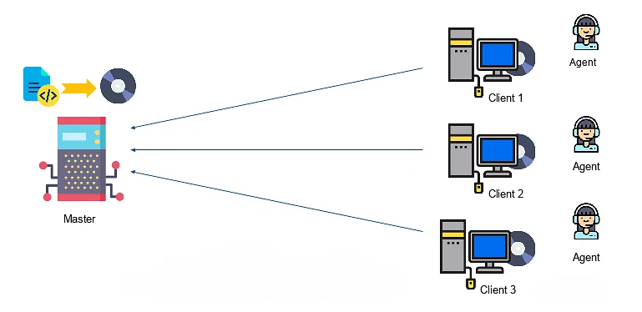

Clients within the network communicate with the primary-secondary environment, where puppet modules are stored. To establish secure and verifiable communication, the client agent initiates the process by sending a certificate bearing its unique ID to the server. The server then performs the critical task of signing the certificate, which is subsequently returned to the client, confirming its identity.
Puppet, from Puppet Labs, is a configuration management tool that helps system administrators automate the provisioning, configuration, and management of a server infrastructure. Planning ahead and using config management tools like Puppet can cut down on time spent repeating basic tasks, and help ensure that your configurations are consistent and accurate across your infrastructure. Once you get the hang of managing your servers with Puppet and other automation tools, you will free up time which can be spent improving other aspects of your overall setup.
Puppet comes in two varieties, Puppet Enterprise and open source Puppet. It runs on most Linux distributions, various UNIX platforms, and Windows.

Step-by-Step: Install & Configure Puppet (Pull-Based) on Ubuntu (Agent Mode)
Since WSL is acting like an Ubuntu VM, you can install Puppet Agent on it — and point it to a Puppet Server (you can install one later on another machine or on the same Windows host via another VM).

Step 1: Enter Ubuntu Shell
If you're not already inside Ubuntu, start it from PowerShell:
& "$env:WINDIR\System32\wsl.exe" -d Ubuntu
You should now see a Linux-style prompt like:
yourname@LAPTOP:~$

Step 2: Install Puppet Agent in Ubuntu
Run these commands inside the Ubuntu shell:
# Add Puppet repository
wget https://apt.puppet.com/puppet8-release-jammy.deb
sudo dpkg -i puppet8-release-jammy.deb
sudo apt-get update

# Install Puppet agent
sudo apt-get install -y puppet-agent

✅ Step 3: Configure the Agent
Edit /etc/puppetlabs/puppet/puppet.conf:
sudo nano /etc/puppetlabs/puppet/puppet.conf
Add this:
[main]
server = puppet.example.com # <-- replace with your Puppet Server hostname or IP
certname = ubuntu-wsl.example.com
environment = production

✅ Step 4: Start the Pull (Cert Request)
sudo /opt/puppetlabs/bin/puppet agent -t
This will contact the server and request signing.

✅ Step 5: On Puppet Server, approve the cert:
sudo /opt/puppetlabs/bin/puppetserver ca list
sudo /opt/puppetlabs/bin/puppetserver ca sign --certname ubuntu-wsl.example.com

✅ Step 6: Apply Configuration
On the agent (your Ubuntu WSL), run:
sudo /opt/puppetlabs/bin/puppet agent -t

